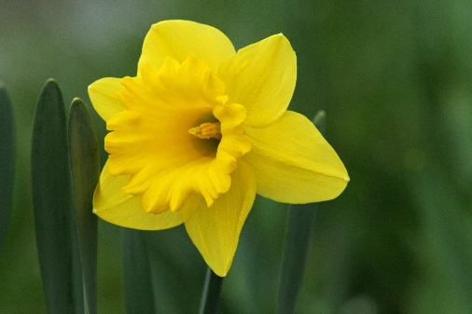  daffodil | 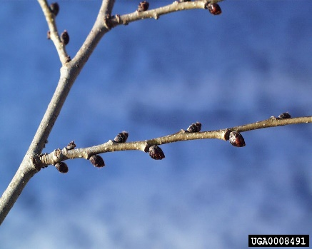  This Photo by Unknown Author is licensed under CC BY  buds on trees | 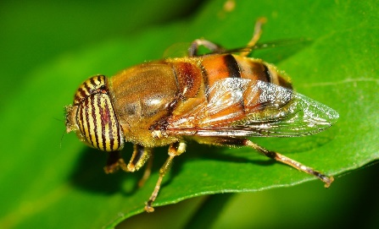  flying insects | 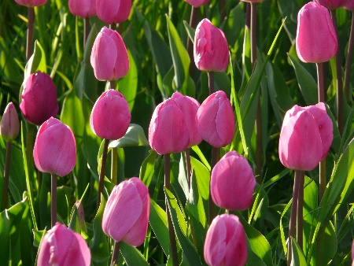  tulip
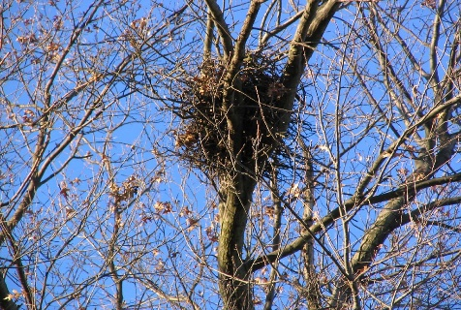  This Photo by Unknown Author is licensed under CC BY-SA  nest | 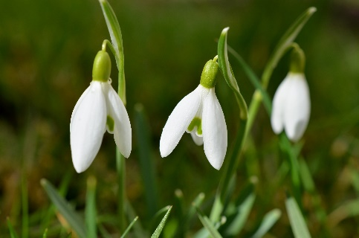  snowdrops | 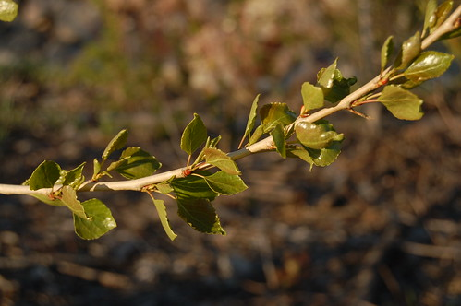  This Photo by Unknown Author is licensed under CC BY-SA-NC  new leaves | 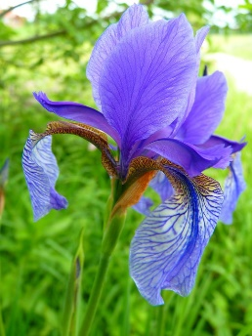  iris

