HOPS CLASS – YEAR A
EXPLORERS & ADVENTURERS
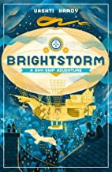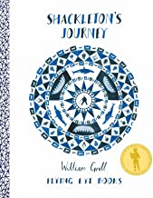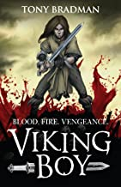
Diversity Theme: Disability without boundaries
Developing character: Never giving up
Learning through experience: Ancient Technology Centre Visit
Oracy: Practise speaking to others in their families and community to raise money.
Project: Guide and/or disability dogs – school visitor, followed by fundraising project.
History: Why were the Vikings successful?
Geog: Understanding of the world – where do our explorers and adventurers go?
Art: Hot air balloons over landmarks – pastels &.Long Boat Collage
DT: Design & make a product that explores movement with gears
Science: Animals including humans
RE: Emmanuel Project Rolling Programme

PSHE: See PSHE 2 Year Rolling Programme
Computing: Information technology / Computer science
Music: Singing and listening & appraising
PE: Gymnastics – Tag rugby/football
MFL: See Year Grp plans from Language Angels

BLUE PLANET
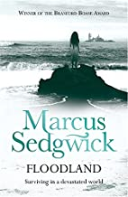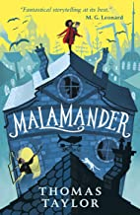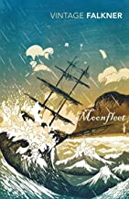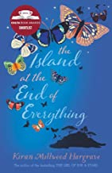
Diversity Theme: Who are the heroes? challenging stereotypes
Developing Character: How can I make a difference?
Learning through experience: Lulworth Education
Oracy: Present recycling project to different groups in the school (including adults) – encourage school community to make changes
Project: Recycling project in school and in our town
History: /
Geog: Coastal features and processes -impact of the sea on human activity
Art: Collaborative painting inspired by Hokusai Great Wave & Sewing of sea creatures
DT: Bird boxes & food technology
Science: Forces & Electricity
RE: Emmanuel Project Rolling Programme

PSHE: See PSHE 2 Year Rolling Programme
Computing: Digital literacy & e-safety / information technology
Music: Notation and playing
PE: Hockey/netball – dance
MFL: See Year Grp plans from Language Angels

GLORIOUS GREEKS
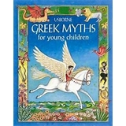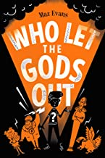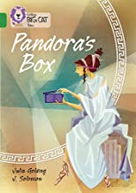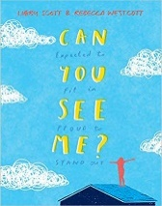
Diversity Theme: Neurodiversity
Developing character: Celebrating difference
Learning through experience: Summer term residentials
Oracy: Create a series of short films about various areas of neuro-diversity
Project: Performance: Pandora’s Box
History: What did the Ancient Greeks do for us?
Geog: Yr 5 Field Study at Leeson House
Art: Greek vases and printed patterns
DT: Make a Greek chariot & plan a Greek banquet
Science: Habitats
Earth and Space (Yr 5s)
Evolution and Inheritance (Yr 6s)

RE: Emmanuel Project Rolling Programme

PSHE: See PSHE 2 Year Rolling Programme
Computing: Digital literacy & e-safety / computer science
Music: Creating and musicianship & performing
PE: Tennis/rounders – athletics – adventurous activities
MFL: See Year Grp plans from Language Angels

HOPS CLASS – YEAR B
WARS AND BATTLES
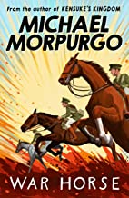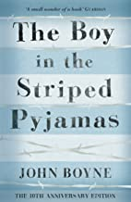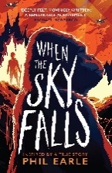
Diversity Theme: Accepting different religious and spiritual beliefs
Developing Character: Reaching out to others
Learning through experience: Nothe Fort Visit
Oracy: Children to lead our school remembrance service
Project: Fundraising project (cake stall/toy stall) for War Child. School to take part in the shoe box project
History: What was life like for people during World War 1 and World War 2?
Geog: /
Art: Alan Morre: Silhouette soldier drawings & Clay poppies
DT: Make a lighthouse with working light &Food technology
Science: Animals including humans
RE: Emmanuel Project Rolling Programme

PSHE: See PSHE 2 Year Rolling Programme
Music: Singing and listening & appraising
Computing: Information technology / Computer science
MFL: See Year Grp plans from Language Angels
PE: Gymnastics – Tag rugby/football

PERILIOUS JOURNEYS
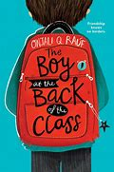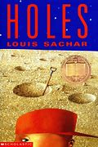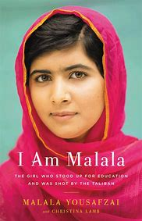
Diversity Theme: Self-identity and belonging
Developing Character: Courage and bravery
Learning through experience: Planetarium visit to the school
Oracy: Singing performance
Project: Plan a family evening walk (look at the night sky) through Gillingham, ending with performing a song at Waitrose.
History: /
Geog: Volcano’s and Earthquakes
Art: Banksy: Artwork with a message & Life Journey collage
DT: Design and build a boat that uses pneumatics
Science: Forces & Electricity, Light
RE: Emmanuel Project Rolling Programme

PSHE: See PSHE 2 Year Rolling Programme
Computing: Digital literacy & e-safety / information technology
Music: Notation and playing
PE: Hockey/netball - dance
MFL: See Year Grp plans from Language Angels

INVENTIONS - VICTORIAN
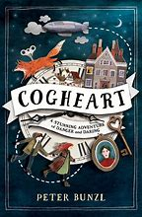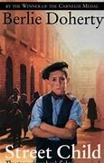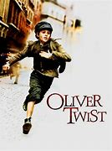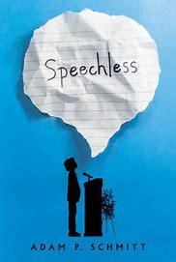
Diversity Theme: Class and Income
Developing Character: Independence
Learning through experience: Scaplens Court visit. Summer term residentials
Oracy: Performance of Olivia
Project: Invite wider community to watch our performance
History: The Victorians: Golden age or dark age?
Geog: Y5 Field Study at Leeson House Changes of land use. Map skills: location of railways
Art: William Morris: design and make wallpaper & creating samplers
DT: Design and make a toy that uses cams
Science: Habitats
Earth and Space (Yr 5)
Evolution and Inheritance (Yr 6)
RE: Emmanuel Project Rolling Programme

Music: Creating and musicianship & performing
PSHE: See PSHE 2 Year Rolling Programme
Computing: : Digital literacy & e-safety / computer science
PE: Tennis/rounders – athletics – adventurous activities
MFL: See Year Grp plans from Language Angels

HOPS CLASS – YEAR C
RIVER DEEP MOUNTAIN HIGH
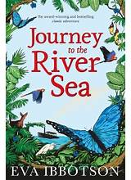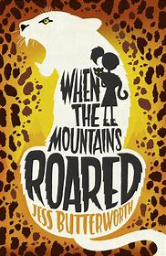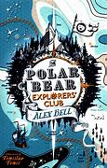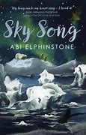
Diversity Theme: Gender stereotypes
Developing Character: Caring for our environment, locally and globally
Learning through experience: Mill on the Brue – river activities
Oracy: Learn and perform: What a wonderful world
Project: Global environment: Family learning day for Water Aid.
History: /
Geog: Rivers and their impact, Living in the Mountains
Art: Monet - pastels drawings of rivers & paper mache mountains
DT: Constructing bridges
Science: Animals including humans
RE: Emmanuel Project Rolling Programme

PSHE: See PSHE 2 Year Rolling Programme
Computing: Information technology / Computer science
Music: Singing and listening & appraising
PE: Gymnastics – Tag rugby/football
MFL: See Year Grp plans from Language Angels

TIME TRAVEL
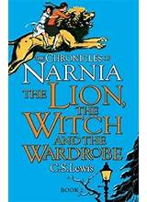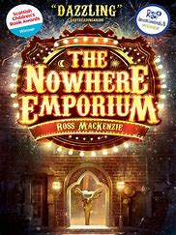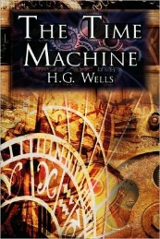
Diversity Theme: Anti-Bullying
Developing Character: Standing up for others
Learning through experience: Visit to the Natural History Museum
Oracy: Write, learn and perform a poetry slam
Project: Enterprise: sell hot chocolate/cakes at the end of the school day to raise money to buy resources to support children at playtimes
History: How do we know about history? Study: Anglo Saxons & Ancient Mayans
Geog: /
Art: Kurt Schwitters: Key hole of Narnia scene & Mayan City Collage
DT: Food technology
Science: Forces & Electricity, Light
RE: Emmanuel Project Rolling Programme

PSHE: See PSHE 2 Year Rolling Programme
Computing: Digital literacy & e-safety / information technology
Music: Notation and playing
PE: Hockey/netball - dance
MFL: See Year Grp plans from Language Angels

WALKING IN SOMEBODY ELSE’S SHOES
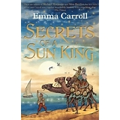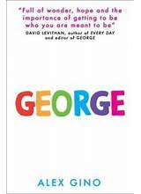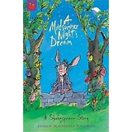
Diversity Theme: Transgender
Developing Character: Preparing for change
Learning through experience: Summer term residentials and Young Shakespeare company visit
Oracy: Performance of A Mid-Summer Nights Dream
Project: Create a walking mindful map for Gillingham – highlighting the quieter places to enjoy.
History: Who were the Ancient Egyptians and what did they believe?
Geog: Y5 Field Study at Leeson House
Art: Hieroglyphic stamp print & Sewing
DT: Paper mache Egyptian masks
Science: Habitats, Earth and Space (Yr 5), Evolution and Inheritance (Yr 6)
RE: Emmanuel Project Rolling Programme

PSHE: See PSHE 2 Year Rolling Programme
Computing: Digital literacy & e-safety / computer science
Music: Creating and musicianship & performing
PE: Tennis/rounders – athletics – adventurous activities
MFL: See Year Grp plans from Language Angels

