Long Term Curriculum, Wheat Class, Year A
TOPIC TITLE – Mythical Monsters
Core Texts
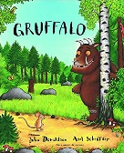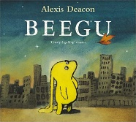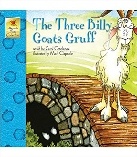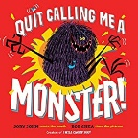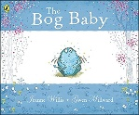
Diversity Theme: Individual, special and unique
Developing Character: Kindness & Active Listening
Learning through experience: Theatre Visit
Oracy: Group retelling of The Gruffalo
Project: Monster Book Sale
Geography: Hot & cold parts of the world & make up of the UK. Continents & Oceans
Art: Pencil drawn characters and clay monsters
DT: Make monster biscuits & puppets
Science: Animals, including humans & seasonal change. Living things & their habitats
RE: Follow 2 year rolling programme based on Emmanuel Project
PSHE: Follow 2 year rolling plan from PSHE Association Scheme
Computing: Information Technology & Computer Science
Music: Singing & Listening & Appraising
PE: Gymnastics & dance

TOPIC TITLE - Jungle
Core Texts
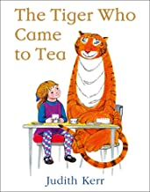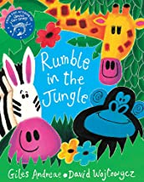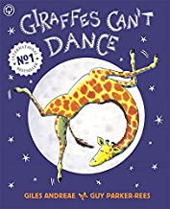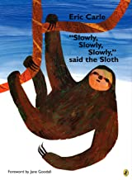
Diversity Theme: Celebrating difference
Developing Character: Teamwork & Resilience
Learning through experience: Longleat Trip
Oracy: Manners at our tea party
Project: Fairtrade Tea party for governors
History: Significant people
Geography: Jungles & rainforests
Art: Jungle painting & jungle camouflage collage
DT: Make a moving creature (y1 sliders Y2 levers)
Science: Everyday materials
RE: Follow 2 year rolling programme based on Emmanuel Project
PSHE: Follow 2 year rolling plan from PSHE Association Scheme
Computing: Digital Literacy & E-safety & Information Technology
Music: Playing & Notation
PE: Multi-skills & gymnastics

TOPIC TITLE – Long, long ago
Core Texts
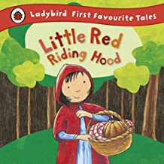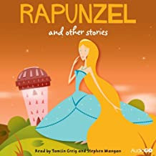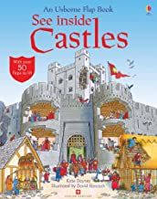
Diversity Theme: Stereotypes
Developing Character: Perseverance & Independence
Learning through experience: Ancient Technology Centre
Oracy: Storytelling with actions of Traditional Tale
Project: Make an exhibit for Gillingham Museum
History: Who were the Romans?
Art: Castle prints & plaiting/twisting materials
DT: Make a cardboard shield & ice lollies
Science: Plants
RE: Follow 2 year rolling programme based on Emmanuel Project
PSHE: Follow 2 year rolling plan from PSHE Association Scheme
Computing: Digital Literacy & E-safety & Computer Science
Music: Creating & Musicianship & Performing
PE: Ball skills & dance & athletics

Long Term Curriculum, Wheat Class, Year B
TOPIC TITLE – Incredible Me
Core Texts
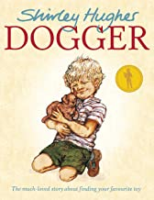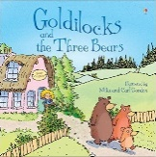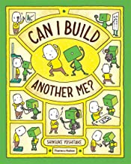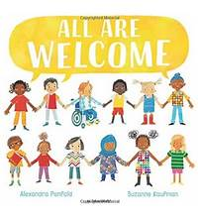
Diversity Theme: Differences & acceptance
Developing Character: Kindness & Active Listening
Learning through experience: Adventure Trip
Oracy: 1 minute videos/assembly ‘I’m incredible’
Project: Make Christmas decorations to sell
History: How has school changed over time?
Geography: Land use in contrasting locations
Art: Self portraits & furniture modelling
DT: Split pin moving people & fruit kebabs(Y1) picnic (Y2) & Christmas decorations
Science: Animals, including humans & seasonal change. Living things & their habitats
RE: Follow 2 year rolling programme based on Emmanuel Project
PSHE: Follow 2 year rolling plan from PSHE Association Scheme
Computing: Information Technology & Computer Science
Music: Singing & Listening & Appraising
PE: Gymnastics & dance

TOPIC TITLE – Urban Vs Rural
Core Texts
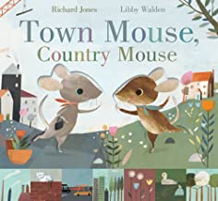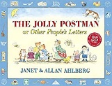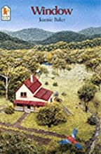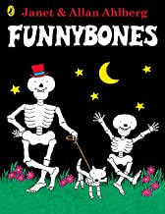
Diversity Theme: Compassion
Developing Character: Teamwork & Resilience
Learning through experience: Farm Visit
Oracy: Questions about a Mosque
Project: Make Easter cards and egg collection for elderly
History: What was farming like in the past?
Geography: Town & country
Art: People paintings & window paper collage
DT: Make bridges & make vegetable soup
Science: Everyday materials
RE: Follow 2 year rolling programme based on Emmanuel Project
PSHE: Follow 2 year rolling plan from PSHE Association Scheme
Computing: Digital Literacy & E-safety & Information Technology
Music: Playing & Notation
PE: Multi-skills & gymnastics

TOPIC TITLE – Stones & Bones
Core Texts
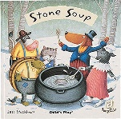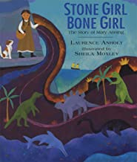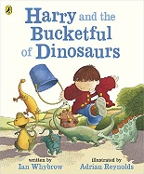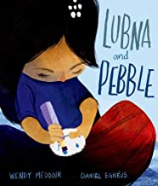
Diversity Theme: Refugees
Developing Character: Perseverance & Independence
Learning through experience: Stonehenge
Oracy: Retelling of Stone Soup
Project: Clothes donation/ raise money for Refugees
History: How do we know that dinosaurs existed?
Art: Dinosaur prints & sock puppets
DT: Make a stone henge, fossil printing & firepit cooking
Science: Plants
RE: Follow 2 year rolling programme based on Emmanuel Project
PSHE: Follow 2 year rolling plan from PSHE Association Scheme
Computing: Digital Literacy & E-safety & Computer Science
Music: Creating & Musicianship & Performing
PE: Ball skills & dance & athletics

Long Term Curriculum, Wheat Class, Year C
TOPIC TITLE – Mishap & Mend
Core Texts
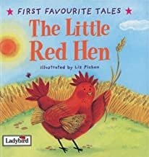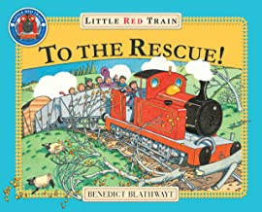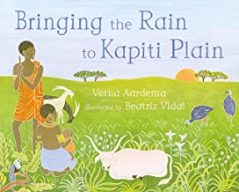
Diversity / PSHE Theme: Teamwork & environment
Developing Character: Kindness & Active Listening
Learning through experience: Visit a Bakers
Oracy: Retelling of The Little Red Hen
Project: Bake a Cake Sale to raise money
History: What caused the Great Fire of London?
Geography: London focus
Art: Computer shape pictures & Tudor house junk models
DT: Making breads & sewing felt butterflies
Science: Animals, including humans & seasonal change. Living things & their habitats
RE: Follow 2 year rolling programme based on Emmanuel Project
PSHE: Follow 2 year rolling plan from PSHE Association Scheme
Computing: Information Technology & Computer Science
Music: Singing & Listening & Appraising
PE: Gymnastics & dance
TOPIC TITLE – Extreme Weather
Core Texts
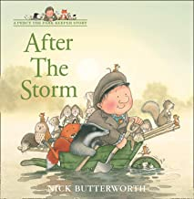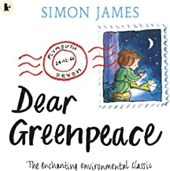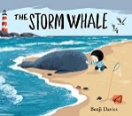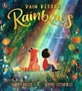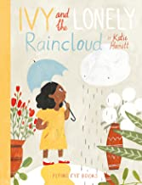
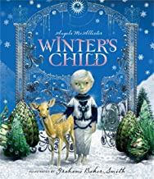
Diversity/PSHE Theme: Environment, loneliness
Developing Character: Teamwork & Resilience
Learning through experience: Hauser & Wirth Gallery
Oracy: Talk about ‘ how we can all help to save water’
Project: Saving water: raise money for charity Wateraid
Geography: Weather
Art: Weather paintings and nature collage
DT: Making kites, windmills, wind chimes, wind socks
Science: Everyday materials
RE: Follow 2 year rolling programme based on Emmanuel Project
PSHE: Follow 2 year rolling plan from PSHE Association Scheme
Computing: Digital Literacy & E-safety & Information Technology
Music: Playing & Notation
PE: Multi-skills & gymnastics
TOPIC TITLE – Happily Ever After
Core Texts
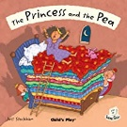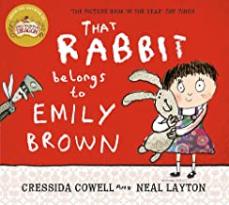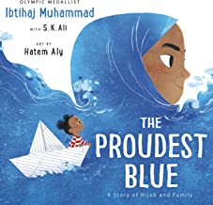
Diversity Theme: Religion & special clothing
Developing Character: Perseverance & Independence
Learning through experience: Wardour Castle Visit
Oracy: Assembly/video about visit to Wardour Castle
Project: Invite parents to king’s/queen’s banquet
History: Why did people build castles?
Art: Wave printing & dream catchers
DT: Planning and making afternoon tea for visitors
Science: Plants
RE: Follow 2 year rolling programme based on Emmanuel Project
PSHE: Follow 2 year rolling plan from PSHE Association Scheme
Computing: Digital Literacy & E-safety & Computer Science
Music: Creating & Musicianship & Performing
PE: Ball skills & dance & athletics

Long Term Curriculum, Oats Class, Year A
TOPIC TITLE – Mythical Monsters
Core Texts
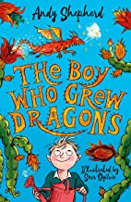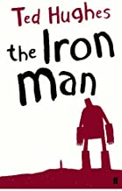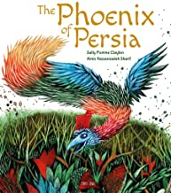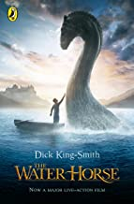
Diversity Theme: Individual, special and unique
Developing Character: Kindness & Active Listening
Learning through experience: Theatre Visit
Oracy: Class recital of ‘Twas the Night Before Christmas’
Project: Monster book sale/swap
Geog: Continents & Oceans & climate
Art: Pencil drawn characters and clay monsters
DT: make monster biscuits and junk model iron man
Science: Living things & their habitats & animals including humans
RE: Follow 2 year rolling programme based on Emmanuel Project
PSHE: Follow 2 year rolling plan from PSHE Association Scheme
Computing: Information Technology & Computer Science
Music: Singing & Listening & Appraising
PE: Gymnastics & Tag rugby/football

TOPIC TITLE - Jungle
Core Texts
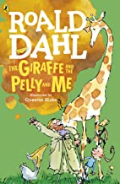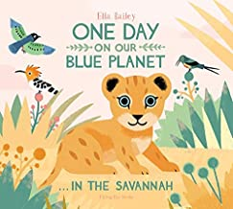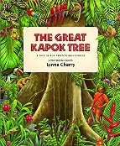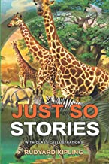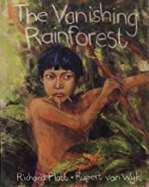
Diversity Theme: Celebrating difference
Developing Character: Teamwork & Resilience
Learning through experience: Longleat Visit
Oracy: Group retelling of Just So story
Project: Rainforest assembly
History: Significant people – Amazon river
Geog: Jungles & rainforests
Art: Jungle painting & jungle camouflage collage
DT: Make a moving creature (Y2 levers Y3 wheeled)
Science: Everyday materials & forces and magnets
RE: Follow 2 year rolling programme based on Emmanuel Project
PSHE: Follow 2 year rolling plan from PSHE Association Scheme
Computing: Digital Literacy & E-safety & Information Technology
Music: Playing & Notation
PE: Dance & hockey/netball

TOPIC TITLE – Long, Long Ago
Core Texts
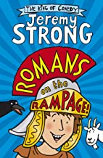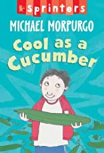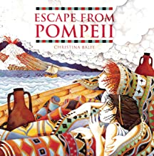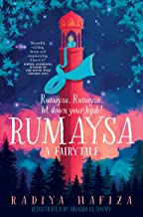
Diversity Theme: Stereotypes
Developing Character: Perseverance & Independence
Learning through experience: Ancient Technology Centre
Oracy: Talk about how things in history have helped us now
Project: Make an exhibit for Gillingham Museum
History: What did the Romans do for us?
Art: Castle prints & plaiting/twisting materials
DT: Make a cardboard shield & make ice lollies
Science: Plants & light & rocks
RE: Follow 2 year rolling programme based on Emmanuel Project
PSHE: Follow 2 year rolling plan from PSHE Association Scheme
Computing: Digital Literacy & E-safety & Computer Science
Music: Creating & Musicianship & Performing
PE: Athletics & cricket/rounders

TOPIC TITLE – Incredible Me
Core Texts
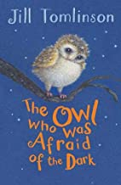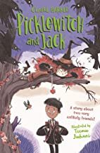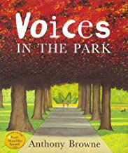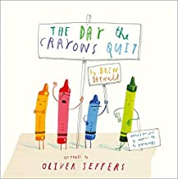
Diversity Theme: Individual, special and unique
Developing Character: Kindness & Active Listening
Learning through experience: Adventure Trip
Oracy: 1 minute video about ‘what’s incredible about me?’
Project: Make Christmas decorations to sell
History: How has school changed over time?
Geog: Land use in contrasting locations
Art: self portraits & furniture modelling
DT: Split pin moving people & make a picnic (Y2) make a pizza (Y3)& Christmas decorations
Science: Living things & their habitats & animals including humans
RE: Follow 2 year rolling programme based on Emmanuel Project
PSHE: Follow 2 year rolling plan from PSHE Association Scheme
Computing: Information Technology & Computer Science
Music: Singing & Listening & Appraising
PE: Gymnastics & Tag rugby/football

Long Term Curriculum, Oats Class, Year B

TOPIC TITLE – Urban vs Rural
Core Texts
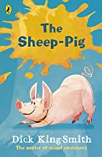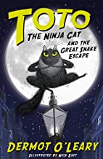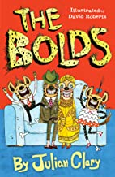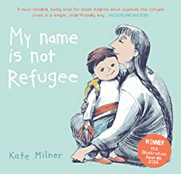
Diversity Theme: Celebrating difference
Developing Character: Teamwork & Resilience
Learning through experience: Farm Visit
Oracy: Questions I want to ask about a Mosque
Project: Make Easter cards and egg collection for elderly
History: How has life for a Farmer changed over time?
Geog: Town and country.
Art: People paintings & window paper collage
DT: Make bridges & make vegetable soup
Science: Everyday materials & forces and magnets
RE: Follow 2 year rolling programme based on Emmanuel Project
PSHE: Follow 2 year rolling plan from PSHE Association Scheme
Computing: Digital Literacy & E-safety & Information Technology
Music: Playing & Notation
PE: Dance & hockey/netball
TOPIC TITLE – Stones & Bones
Core Texts
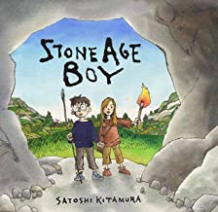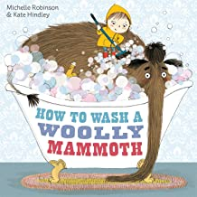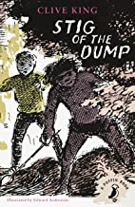
Diversity Theme: Stereotypes
Developing Character: Perseverance & Independence
Learning through experience: Stonehenge
Oracy: Give verbal instructions to others to make an item
Project: Clothes donation for Refugees
History: What does buried treasure tell us about the past?
Art: Dinosaur prints & sock puppets
DT: Make a stone henge, fossil printing & firepit cooking
Science: Plants & light & rocks
RE: Follow 2 year rolling programme based on Emmanuel Project
PSHE: Follow 2 year rolling plan from PSHE Association Scheme
Computing: Digital Literacy & E-safety & Computer Science
Music: Creating & Musicianship & Performing
PE: Athletics & cricket/rounders

TOPIC TITLE – Mishap & Mend
Core Texts
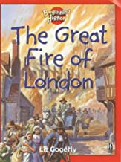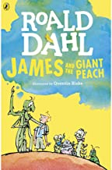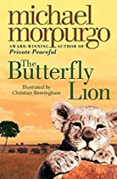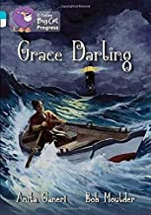
Diversity Theme: Individual, special and unique
Developing Character: Kindness & Active Listening
Learning through experience: Visit a Bakers
Oracy: Role play interview between reporter and Grace Darling
Project: Bake a Cake Sale to raise money
History: What changed as a result of the Great Fire of London?
Art: Computer shape pictures & Tudor house junk models
DT: Making breads & sewing felt butterflies
Science: Living things & their habitats & animals including humans
RE: Follow 2 year rolling programme based on Emmanuel Project
PSHE: Follow 2 year rolling plan from PSHE Association Scheme
Computing: Information Technology & Computer Science
Music: Singing & Listening & Appraising
PE: Gymnastics & Tag rugby/football
Long Term Curriculum, Oats Class, Year C
TOPIC TITLE – Extreme Weather
Core Texts
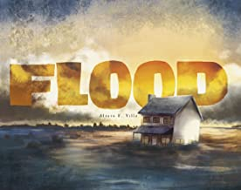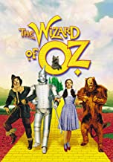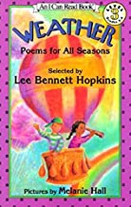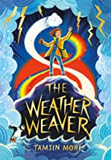
Diversity Theme: Celebrating difference
Developing Character: Teamwork & Resilience
Learning through experience: Hauser & Wirth gallery
Oracy: Recite a weather poem independently
Project: Saving water: raise money for charity Wateraid
Geog: Weather
Art: Weather paintings and nature collage
DT: Making kites, windmills, wind chimes, wind socks
Science: Everyday materials & forces and magnets
RE: Follow 2 year rolling programme based on Emmanuel Project
PSHE: Follow 2 year rolling plan from PSHE Association Scheme
Computing: Digital Literacy & E-safety & Information Technology
Music: Playing & Notation
PE: Dance & hockey/netball

TOPIC TITLE – Happily Ever After
Core Texts
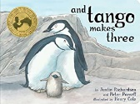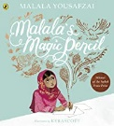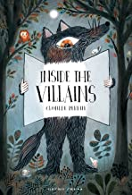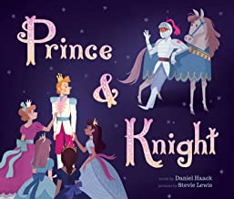

Diversity Theme: Stereotypes
Developing Character: Perseverance & Independence
Learning through experience: Wardour Castle
Oracy: Formal language and manners for banquet
Project: Invite parents to king’s/queen’s banquet
History: Who were the great women who lived in castles?
Art: Wave printing & dream catchers
DT: planning and making afternoon tea for visitors
Science: Plants & light & rocks
RE: Follow 2 year rolling programme based on Emmanuel Project
PSHE: Follow 2 year rolling plan from PSHE Association Scheme
Computing: Digital Literacy & E-safety & Computer Science
Music: Creating & Musicianship & Performing
PE: Athletics & cricket/rounders

