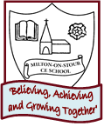
2 weeks
PSHE/ Diversity/Values Link: Looking after each other
Oracy: To give and to follow instructions

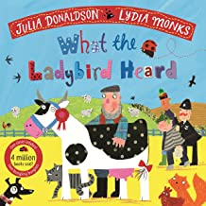
Core Text: What the Ladybird Heard

2 weeks
PSHE/ Diversity/Values Link: Friendships and tolerance
Oracy: To perform as a class the story of the Smeds and the Smoos

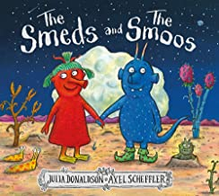
Core Text: The Smeds and the Smoos

PSHE/ Diversity/Values Link: Different Families
Oracy: To talk about the people joined to the invisible thread to their heart

Core Text: A Handful of Buttons
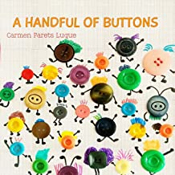
SUMMER 2
Learning through experience: Visit the Library
2 weeks
PSHE/ Diversity/Values Link: Feeling poorly – medicine and safety
Oracy: To talk about giving three examples of how to keep their bodies healthy

Core Text: The Selfish Crocodile
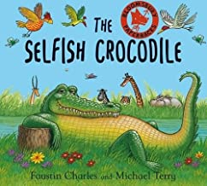

Character Skill: Articulation & Oracy – I can speak loudly and proudly

