
2 weeks
PSHE/ Diversity/Values Link: Behaviour – Right and wrong
Oracy: To retell the story using props or actions

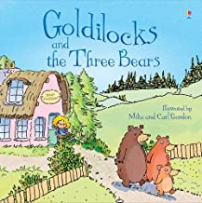
Core Text: Goldilocks and the Three Bears

PSHE/ Diversity/Values Link: Loneliness
Oracy: To use a story map to help retell the story

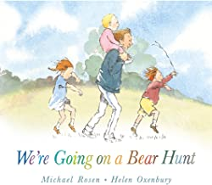
Core Text: We’re going on a Bear Hunt

PSHE/ Diversity/Values Link: Gender stereotypes
Oracy: To describe the items Julian used to dress as a mermaid

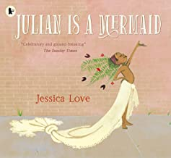
Core Text: Julian is a Mermaid
SUMMER 1
Learning through experience: Sealife Centre Visit
PSHE/ Diversity/Values Link: Keeping myself safe
Oracy: To perform a poem

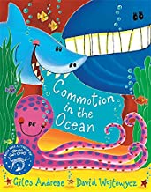
Core Text: Commotion in the Ocean
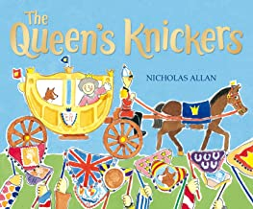
PSHE/ Diversity/Values Link: NSPCC Pants Rule & Manners
Oracy: To practice and perform a formal greeting for the Queen

Core Text: The Queen’s Knickers

Character Skill: Independence

