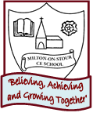
SPRING 2

2 Weeks
PSHE/ Diversity/Values Link: different places & cultures
Oracy: To talk about where in the world their flying carpet goes and describe what they see

Core Text: My Granny went to market
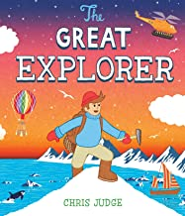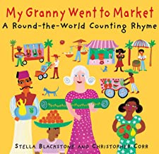

PSHE/ Diversity/Values Link: gender stereotypes
Oracy: To talk about favourite colour and how it makes them feel

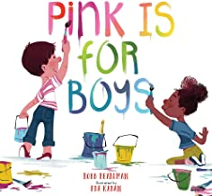
Core Text : Pink is for Boys

Learning through experience: Theatre Visit
2 weeks
PSHE/ Diversity/Values Link: Friendship
Oracy: To compare two fruits using the conjunction ‘but’

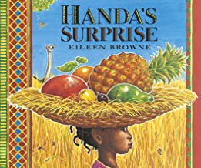
Core Text: Handa’s Surprise
PSHE/ Diversity/Values Link: Being lost and stranger danger
Oracy: To retell the story with actions

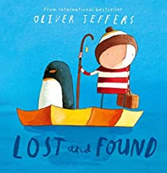
Core Text: Lost and Found
Character Skill: Resilience ‘Never give up’

