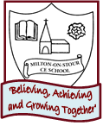
2 weeks
PSHE/ Diversity/Values Link: Goals! What can I achieve?
Oracy: To retell the story using actions

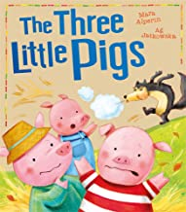
Core Text: The Three Little Pigs

PSHE/ Diversity/Values Link: Healthy bodies and growing.
Oracy: To talk about the four stages in the life cycle of a butterfly using time conjunctions

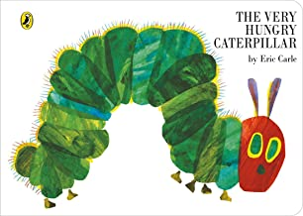
Core text: The Very Hungry Caterpillar

PSHE/ Diversity/Values Link: Healthy eating/ balanced diet
Oracy: To name and describe different fruits using adjectives

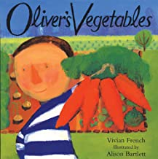
Core Text: Oliver’s Vegetables
SPRING 1
Learning through experience: Fire Service Visit
PSHE/ Diversity/Values Link: Being Scared
Oracy: To be able to describe the Gruffalo using ‘and’ to extend the sentence

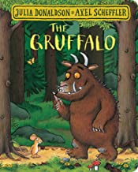
Core Text: The Gruffalo
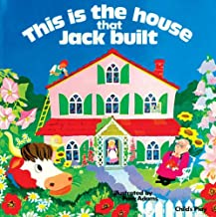
PSHE/ Diversity/Values Link: I am brilliant!
Oracy: To retell the story/rhyme using picture clues

Core Text: This is the House that Jack Built

Character Skill: Always do my best

