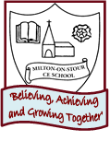
AUTUMN 2
PSHE/ Diversity/Values Link: Helping each other
Oracy: To talk about ways we can work as a Team and help each other

Learning through experience: Garden Centre Visit
Character Skill: Teamwork
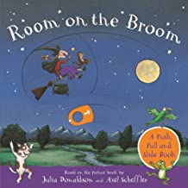
Core Text: Room on a Broom
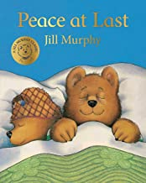
Core Text: Peace at Last
PSHE/ Diversity/Values Link: Sleeping and healthy habits
Oracy: To describe different noises in the environment

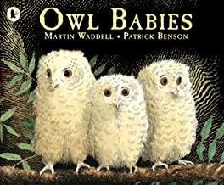
PSHE/ Diversity/Values Link: Missing family members
Oracy: To use puppets and words to perform the story

Core Text: Owl Babies

2 weeks
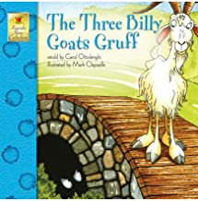
Core Text: The Three Billy Goats Gruff
PSHE/ Diversity/Values Link:
Oracy: To retell the story as a class using actions

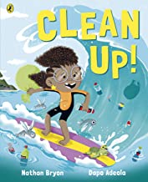
PSHE/ Diversity/Values Link: taking care of the environment
Oracy: To talk about how plastic is damaging the environment

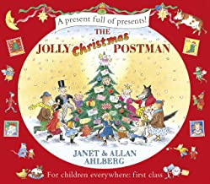
Core Text: Clean Up
Core Text: The Jolly Christmas Postman
PSHE/ Diversity/Values Link: Saying thank you to others
Oracy: To sing and perform a Christmas song

