
Character Skill: Active Listening
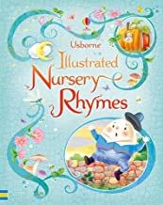
Core Text: Nursery Rhymes

PSHE/ Diversity/Values Link: Class charter & routines
Oracy: To recite and perform a Nursery Rhyme

PSHE/ Diversity/Values Link: Special toys and bedtime incl brushing teeth
Oracy: To perform the story with props

Oracy:

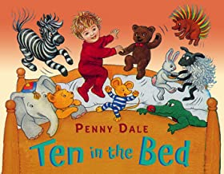
Core Text: Ten in a Bed

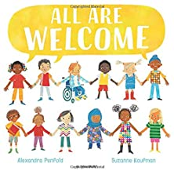
PSHE/ Diversity/Values Link: Celebrating who we are and being kind
Oracy: To talk about what we like at our school

Core Text: All are Welcome
AUTUMN TERM 1
Learning through experience: Police visit
2 weeks
PSHE/ Diversity/Values Link: Different cultures.
Oracy: To retell The Gingerbread man using Pie Corbett storytelling actions

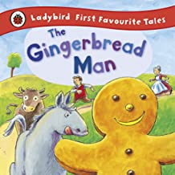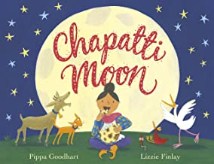
Core Texts: The Gingerbread Man
Chapatti’s Moon
Core Text: Elmer
PSHE/ Diversity/Values Link: Celebrating difference
Oracy: to describe an elephant using colours and shape words

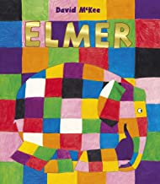

Core Text: The Rainbow Fish
PSHE/ Diversity/Values Link: Kindness & sharing
Oracy: To talk about what they do to be kind.



