Learn to play the Violin or the Viola
Hello! My name is Victoria Mogridge.

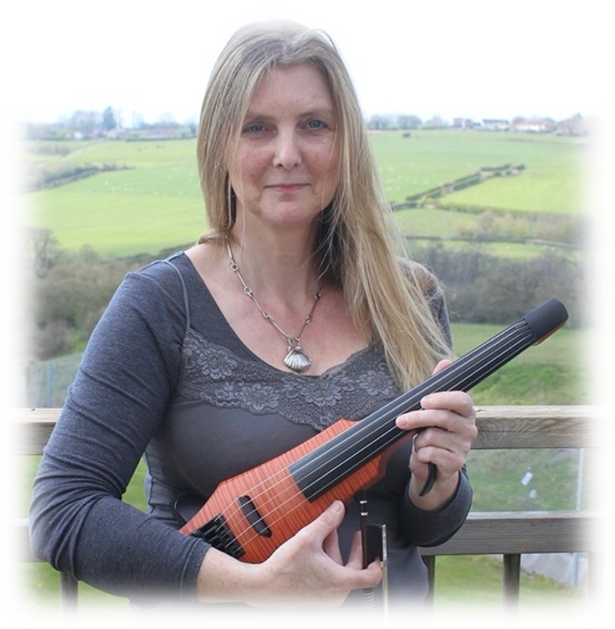
I am a classically trained violinist with over 30 years’ experience of playing as a soloist, in bands and teaching many music students. This includes teaching 5 – 18 years olds from schools in Gillingham and Shaftesbury for their ABRSM and Trinity music exams and completing the practical element of their GCSE and A Level music.

I aim to pass on appreciation of music to my students by maintaining my professional skill and musical diversity through playing in various music festivals in the
southwest. I also play in more local events including Irish ceilidhs, weddings and barn dances. I have supported various recording works as a session musician for CDs, library music and films.

Today, I am a member of the band ‘Unfringed’ who are appearing in August at The Fringe, Shaftesbury, 2021. I will also be soloing as ‘Greylighting’ at The Fringe 2021, playing my own contemporary and traditional music from Britain, Ireland and Scandinavia. For this event I will be showing a more modern side of a string instrument by using an electric violin with five strings, that incorporates the range of a viola. This is an exciting instrument that allows me to introduce different playing techniques, sound range and exotic rhythms associated with more contemporary music.
..

