Milton-on-Stour Primary School Progression in the teaching of Music
 | Singing | Listening & Appraising | Notation | Playing | Creating | Musicianship & Performing
 | Autumn |  | Spring |  | Summer
Reception | To confidently use voices in different ways including singing, speaking and chanting to a steady beat.  Explore how to make high and low sounds.  Make and control fast and slow sounds, loud and quiet and high and low to create mood and show feelings. | Repeat patterns of sounds with increasing accuracy.  Show increasing rhythm and control when responding to music with movement.  To identify sources of sound with accuracy.  To listen to familiar music and talk about when it may be used with support eg – nursery rhyme before bed time. Christmas carol at Christmas etc. | Developing an awareness of when to stop and start using symbols and signals. | To choose sounds and instruments for a specific purpose.  To follow and imitate simple patterns using body movements (clapping etc) percussion instruments with increasing control.  To begin to create own patterns using instruments.  To use percussion instruments to accompany a chant or song independently.  To confidently name classroom instruments. | To begin to create own patterns using instruments  To use percussion instruments to accompany a chant or song independently.  Confidently select and choose own instruments to create own beats and sequences independently and within a group.  Can select and choose instruments to represent and respond to stimulu (weather, parts of a story). | To think about others while performing in a small group session.  To confidently express whether they like or dislike music.  To confidently say and explain why.  To independently think of ways to make their work better.
Year 1 | Sing simple songs, chants and rhymes (e.g. Boom Chicka Boom) from memory, singing collectively and at the same pitch, responding to simple visual directions (e.g. stop, start, loud, quiet) and counting in.  Sing a wide range of call and response songs. | See recommended listening for new model curriculum Appendix 1  Respond to the pulse in recorded/live music through movement and dance, e.g.  Stepping (e.g. Mattachins from Capriol Suite by Warlock),  Jumping (e.g. Trepak from The Nutcracker by Tchaikovsky)  Walking on tiptoes (e.g. Scherzo from The Firebird Suite by Stravinsky).  Listen to sounds in the local school environment, comparing high and low sounds. | Recognise how graphic notation can represent created sounds. Explore and invent own symbols, for example:    Follow pictures and symbols to guide singing and playing, e.g. 4 dots = 4 taps on the drum.  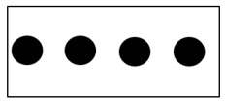 | Use body percussion, (e.g. clapping, tapping, walking) and classroom percussion (shakers, sticks and blocks, etc.), playing repeated rhythm patterns (ostinati) and short, pitched patterns on tuned instruments (e.g. glockenspiels or chime bars) to maintain a steady beat.  Perform short copycat rhythm patterns accurately, led by the teacher.  Explore percussion sounds to enhance storytelling, e.g.  ascending xylophone notes to suggest Jack climbing the beanstalk,  quiet sounds created on a rainstick/shakers to depict a shower,  regular strong beats played on a drum to replicate menacing footsteps. | Improvise simple vocal chants, using question and answer phrases.  Create musical sound effects and short sequences of sounds in response to stimuli, e.g. a rainstorm or a train journey. Combine to make a story, choosing and playing classroom instruments (e.g. rainmaker) or sound-makers (e.g. rustling leaves).  Understand the difference between creating a rhythm pattern and a pitch pattern.  Perform word-pattern chants (e.g. ca-ter-pil-lar crawl, fish and chips); create, retain and perform their own rhythm patterns.  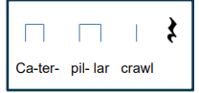  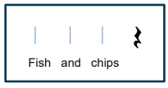 | Invent, retain and recall rhythm and pitch patterns and perform these for others, taking turns.  Walk, move or clap a steady beat with others, changing the speed of the beat as the tempo of the music changes.  Perform short repeating rhythm patterns (ostinati) while keeping in time with a steady beat.  Sing familiar songs in both low and high voices and talk about the difference in sound.
Year 2 | Sing songs with a pitch range of do-so with increasing vocal control.  Sing songs with a small pitch range (e.g. Rain, Rain Go Away), pitching accurately.  Know the meaning of dynamics (loud/quiet) and tempo (fast/slow) and be able to demonstrate these when singing by responding to (a) the leader's directions and (b) visual symbols (e.g. crescendo, decrescendo, pause)  Sing short phrases independently within a singing game or short song. | See recommended listening for new model curriculum Appendix 1  Mark the beat of a listening piece (e.g. Bolero by Ravel) by tapping or clapping and recognising tempo as well as changes in tempo.  Walk in time to the beat of a piece of music or song (e.g. La Mourisque by Susato). Know the difference between left and right to support coordination and shared movement with others.  Identify the beat groupings in familiar music that they sing regularly and listen to, e.g.  in 2 Maple Leaf Rag by Joplin  in 3 The Elephant from Carnival of the Animals by Saint-Saëns | Create rhythms using word phrases as a starting point (e.g. Hel-lo Si-mon or Can you come and play?).  Read and respond to chanted rhythm patterns, and represent them with stick notation including crotchets, quavers and crotchets rests.  Create and perform their own chanted rhythm patterns with the same stick notation. | Begin to group beats in twos and threes by tapping knees on the first (strongest) beat and clapping the remaining beats.  Play copycat rhythms, copying a leader, and invent rhythms for others to copy on untuned percussion.  Recognise dot notation and match it to 3-note tunes played on tuned percussion, for example:   | Create music in response to a non-musical stimulus (e.g. a storm, a car race, or a rocket launch).  Work with a partner to improvise simple question and answer phrases, to be sung and played on untuned percussion, creating a musical conversation.  Use graphic symbols, dot notation and stick notation, as appropriate, to keep a record of composed pieces. | Create rhythms using word phrases as a starting point (e.g. Hel-lo Si-mon or Can you come and play?).  Understand that the speed of the beat can change, creating a faster or slower pace (tempo).  Respond independently to pitch changes heard in short melodic phrases, indicating with actions (e.g. stand up/sit down, hands high/hands low)
Year 3 | Sing a widening range of unison songs of varying styles and structures tunefully and with expression. Perform forte and piano, loud and soft.  Perform actions confidently and in time to a range of action songs (e.g. Heads and Shoulders). | See recommended listening for new model curriculum Appendix 1  Consider the questions to ask when listening to music Appendix 2  Use listening skills to correctly order phrases using dot notation, showing different arrangements of notes C-D-E/do-re-mi (see illustration):  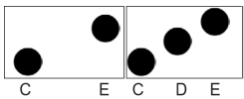  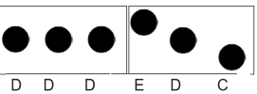 | Introduce the stave, lines and spaces, and clef. Use dot notation to show higher or lower pitch.  Introduce and understand the differences between crotchets and paired quavers.  Apply word chants to rhythms, understanding how to link each syllable to one musical note. | Become more skilled in improvising (using voices, tuned and untuned percussion and instruments), inventing short ‘on-the-spot’ responses using a limited note-range.  Develop facility in playing tuned percussion or melodic instruments  Play and perform melodies following staff notation using a small range (e.g. Middle C–E/do–mi) as a whole class or in small groups | Structure musical ideas (e.g. using echo or question and answer phrases) to create music that has a beginning, middle and end. Pupils should compose in response to different stimuli, e.g. stories, verse, images (paintings and photographs) and musical sources.  Combine known rhythmic notation with letter names to create rising and falling  phrases using just three notes (do, re and mi).  Compose song accompaniments on untuned percussion using known rhythms and note values. | Walk, move or clap a steady beat with others, changing the speed of the beat as the tempo of the music changes.  Individually (solo) copy stepwise melodic phrases with accuracy at different speeds; allegro and adagio, fast and slow. Extend to question-and-answer phrases.  Perform as a choir in school assemblies.
Year 4 | Continue to sing a broad range of unison songs pitching the voice accurately and following directions for getting louder (crescendo) and quieter (decrescendo).  Sing rounds and partner songs in different time signatures (2, 3 and 4 time) (e.g. Our Dustbin) and begin to sing repertoire with small and large leaps as well as a simple second part to introduce vocal harmony (e.g. Hear the Wind). | See recommended listening for new model curriculum Appendix 1  Consider the questions to ask when listening to music Appendix 2  Introduce major and minor chords. | Arrange individual notation cards of known note values (i.e. minim, crotchet, crotchet rest and paired quavers) to create sequences of 2-, 3- or 4-beat phrases, arranged into bars.  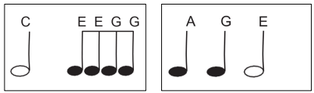  Introduce and understand the differences between minims, crotchets, paired quavers and rests. | Improvise on a limited range of pitches on the instrument they are now learning, making use of musical features including smooth (legato) and detached (staccato).  Copy short melodic phrases  Play and perform melodies following staff notation using a small range (e.g. Middle C–G/do–so) as a whole-class or in small groups.  Develop facility in the basic skills of a selected musical instrument over a sustained learning period. | Combine known rhythmic notation with letter names to create short pentatonic phrases using a limited range of 5 pitches suitable for the instruments being learnt. Sing and play these phrases as self-standing compositions.  Explore developing knowledge of musical components by composing music to create a specific mood, for example creating music to accompany a short film clip.  Capture and record creative ideas using any of:  graphic symbols  rhythm notation and time signatures  staff notation | Perform a range of songs in school assemblies  Perform in two or more parts (e.g. melody and accompaniment or a duet) from simple notation using instruments played in whole class teaching.  Read and perform pitch notation within a defined range (e.g. C–G/do–so). •  Follow and perform simple rhythmic scores to a steady beat: maintain individual parts accurately within the rhythmic texture, achieving a sense of ensemble.
Year 5 | Sing a broad range of songs from an extended repertoire with a sense of ensemble and performance. This should include observing phrasing, accurate pitching and appropriate style.  Sing three-part rounds, partner songs, and songs with a verse and a chorus. | See recommended listening for new model curriculum Appendix 1  Consider the questions to ask when listening to music Appendix 2 | Further understand the differences between semibreves, minims, crotchets and crotchet rests, paired quavers and semiquavers.  Understand the differences between 2/4, 3/4 and 4/4 time signatures.  Read and perform pitch notation within an octave (e.g. C–C′/do–do).  Read and play short rhythmic phrases at sight from prepared cards, using conventional symbols for known rhythms and note durations. | Improvise freely over a drone, developing sense of shape and character, using tuned percussion and melodic instruments.  Play melodies on tuned percussion, melodic instruments or keyboards, following staff notation written on one stave and using notes within the Middle C–C′/do–do range. This should initially be done as a whole class with greater independence gained each lesson through smaller group performance.  Understand how triads are formed, and play them on tuned percussion, melodic instruments or keyboards. Perform simple, chordal accompaniments to familiar songs (e.g. Yellow Submarine by The Beatles).  Develop the skill of playing by ear on tuned instruments, copying longer phrases and familiar melodies. | Improvise over a simple groove, responding to the beat, creating a satisfying melodic shape; experiment with using a wider range of dynamics, including very loud (fortissimo), very quiet (pianissimo), moderately loud (mezzo forte), and moderately quiet (mezzo piano). Continue this process in the composition tasks below.  Compose melodies made from pairs of phrases in either C major or A minor or a key suitable for the instrument chosen. These melodies can be enhanced with rhythmic or chordal accompaniment.  Working in pairs, compose a short ternary piece.  Use chords to compose music to evoke a specific atmosphere, mood or environment. For example, La Mer by Debussy and The River Flows In You by Yiruma both evoke images of water. Equally, pupils might create music to accompany a silent film or to set a scene in a play or book.  Capture and record creative ideas using any of:  graphic symbols  rhythm notation and time signatures  staff notation | Perform a range of songs in school assemblies and in school performance opportunities.  Perform a range of repertoire pieces and arrangements combining acoustic instruments to form mixed ensembles
Year 6 | Sing a broad range of songs, including those that involve syncopated rhythms, as part of a choir, with a sense of ensemble and performance. Include observing rhythm, phrasing, accurate pitching and appropriate style.  Continue to sing three- and four-part rounds (e.g. Calypso by Jan Holdstock) or partner songs, and experiment with positioning singers randomly within the group – i.e. no longer in discrete parts – in order to develop greater listening skills, balance between parts and vocal independence. | See recommended listening for new model curriculum Appendix 1  Consider the questions to ask when listening to music Appendix 2 | Further understand the differences between semibreves, minims, crotchets, quavers and semiquavers, and their equivalent rests.  Further develop the skills to read and perform pitch notation within an octave (e.g. C–C/ do–do).  Read and play confidently from rhythm notation cards and rhythmic scores in up to 4 parts that contain known rhythms and note durations.  Read and play from notation a four-bar phrase, confidently identifying note names and durations. | Extend improvisation skills through working in small groups to:  • Create music with multiple sections that include repetition and contrast.  • Use chord changes as part of an improvised sequence.  • Extend improvised melodies beyond 8 beats over a fixed groove, creating a satisfying melodic shape.  Play a melody following staff notation written on one stave and using notes within an octave range (do–do); make decisions about dynamic range, including very loud (ff ), very quiet (pp ), moderately loud (mf ) and moderately quiet (mp ).  Accompany this same melody, and others, using block chords or a bass line. This could be done using keyboards, tuned percussion or tablets, or demonstrated at the board using an online keyboard.  Engage with others through ensemble playing | Plan and compose an 8- or 16-beat melodic phrase using the pentatonic scale (e.g. C, D, E, G, A) and incorporate rhythmic variety and interest. Play this melody on available tuned percussion and/or orchestral instruments. Notate this melody.  Compose melodies made from pairs of phrases in either G major or E minor or a key suitable for the instrument chosen.  Compose a ternary piece; use available music software/apps to create and record it, discussing how musical contrasts are achieved. | Perform a range of songs as a choir in school assemblies, school performance opportunities and to a wider audience.

Appendix 1
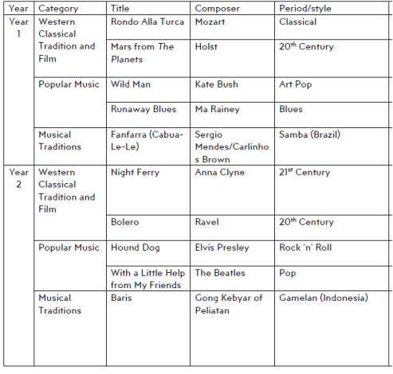
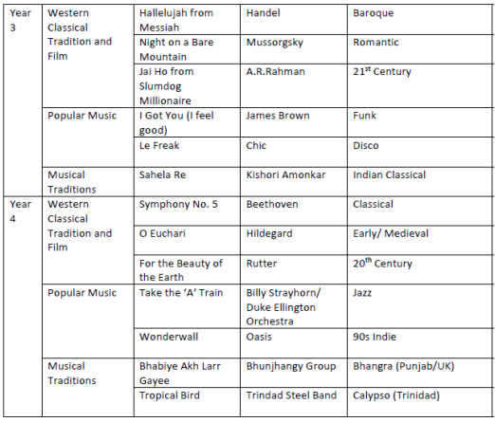
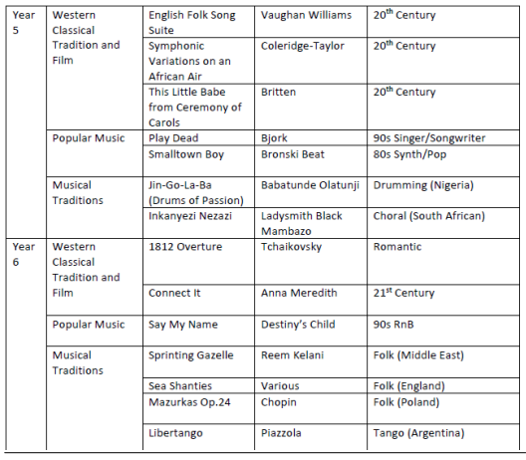
Appendix 2
QUESTIONS TO ASK WHEN LISTENING TO MUSIC KEY STAGE 2
General
Do you like this music? Why? Why not?
What do you think this music is about?
Why do you think this music was written?
Who do you think wrote this piece of music?
What title would you give this piece of music?
What style do you think this music is?
Have you heard this music before?
How did the music make you feel?
Where in the world do you think this music is from?
Is this piece similar like any other music you enjoy listening to? In what way?
What type of group is playing this music? (orchestra, jazz band, rock)
Can you describe the music in one word? Why did you choose that word?
Specific
Can you identify where one section ends and the next begins?
What is the structure of this piece of music?
Are there any repeated sections or ideas in this piece?
How do you think the composer reflected the idea of ‘x’ in his music?
What is the same/different about these pieces of music?
Do you think this music is in a major (happy) or minor (sad) key?
Does the music move in groups of two, three or four?
What time signature do you think this piece of music is in?
Which instrument do you think is playing the accompaniment/ melody?
What do you notice about the pitch/dynamics/tempo/texture/timbre at this point in the music?
Is the texture of the music thick or thin? Does the texture stay the same throughout?
How do you think the instrument is being played? Blown, plucked, bowed or struck?
What patterns did you notice in the music?
What were the lyrics about (if it had lyrics)?
Do any instruments play a solo?

